视频P40〜P41：https://www.bilibili.com/video/BV18L4y1M7Bd?p=40

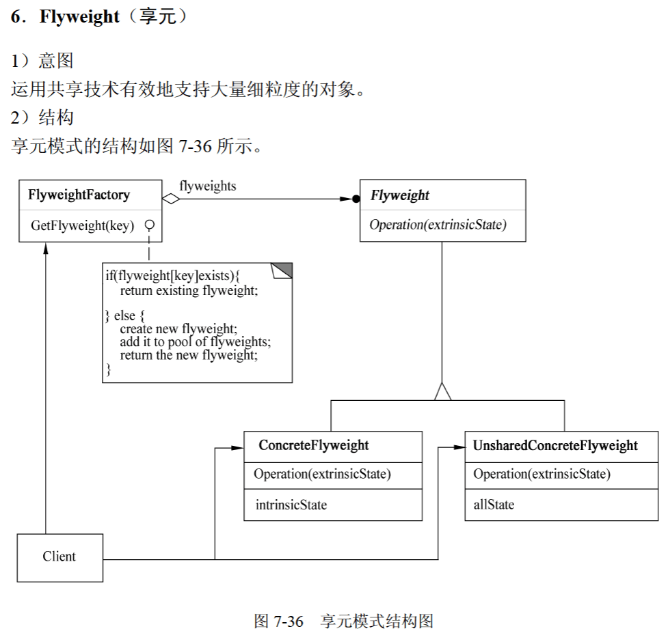
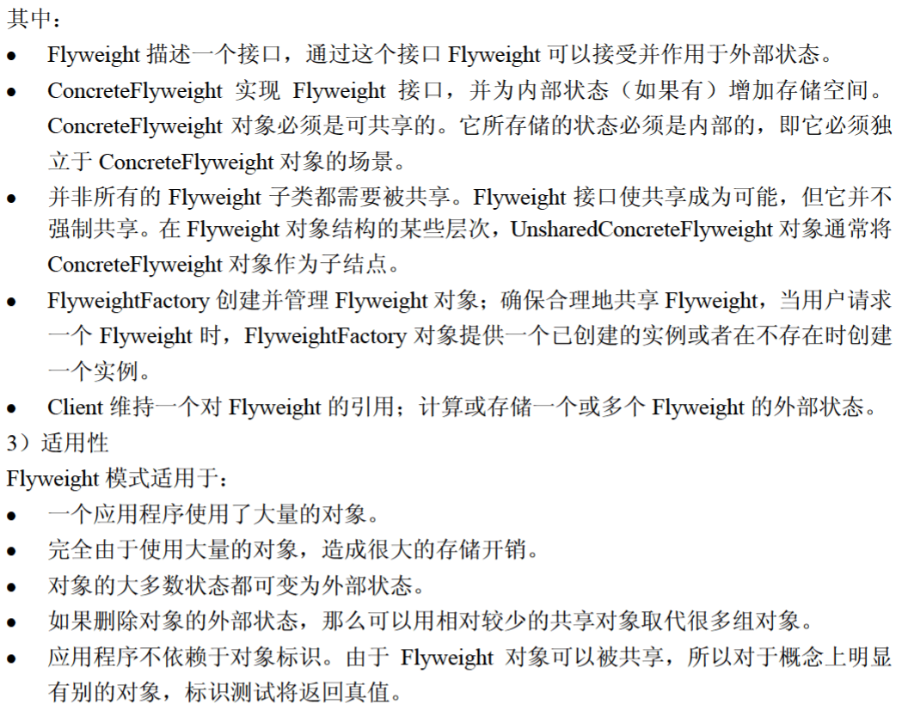

享元模式
因使用大量的对象而造成很大的存储开销时，适合采用 （47） 模式进行对象共享，以减少对象数量从而达到较少的内存占用并提升性能。（2016年上半年）
（47） A. 组合（Composite） B. 享元（Flyweight）
C. 迭代器（Iterator） D. 备忘（Memento）

代码
import java.util.*;

public class FlyWeightPattern {
public static void main(String[] args) {
ShapeFactory factory = new ShapeFactory();

Random random = new Random();
String[] colors = {"red", "blue", "green", "white", "black"};

for (int i = 1; i <= 100; i ++ ) {
int x = random.nextInt(colors.length); // [0 ~ 4]
Shape shape = factory.getShape(colors[x]);

System.out.print("第" + i + "个圆：");
shape.draw(random.nextInt(2022), random.nextInt(528));
}
}
}

class ShapeFactory {
private Map<String, Shape> map = new HashMap<String, Shape>();

public Shape getShape(String key) {
if (!map.containsKey(key)) {
map.put(key, new Circle(key));
System.out.println("create color：" + key + " circle");
}

return map.get(key);
}
}

abstract class Shape {
protected String color;

public abstract void draw(int x, int y);
}

class Circle extends Shape {
public Circle(String color) {
this.color = color;
}

@Override
public void draw(int x, int y) {
System.out.println("draw a color：" + color + " circle x：" + x + " y：" + y);
}
}

