视频P50：https://www.bilibili.com/video/BV18L4y1M7Bd?p=50

解释器模式
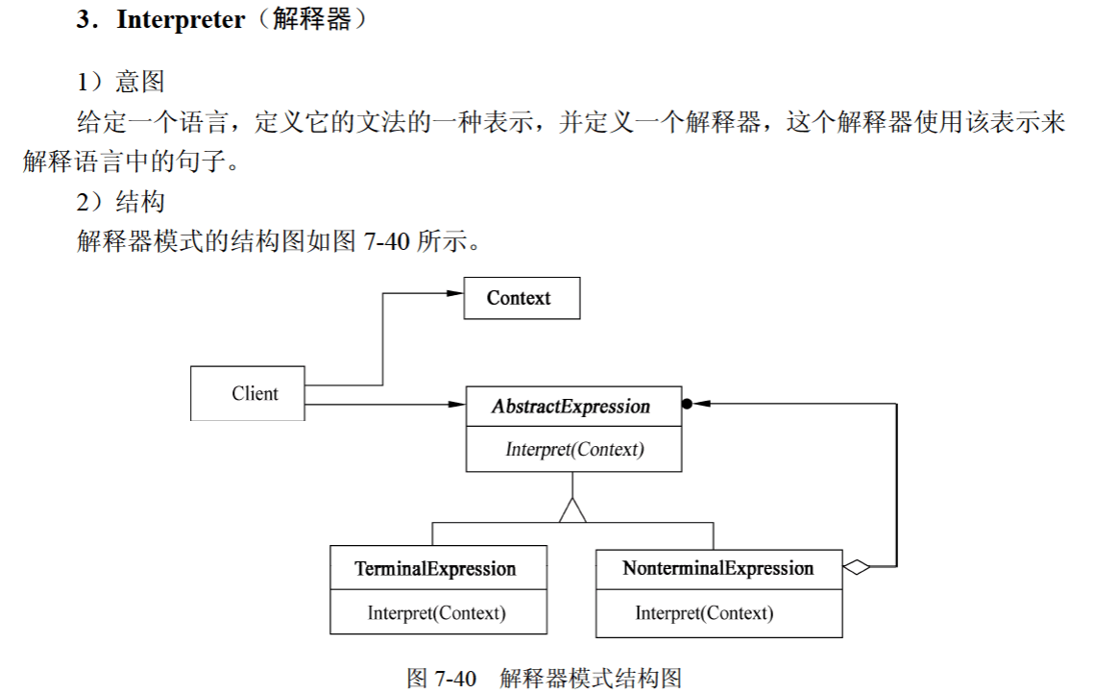
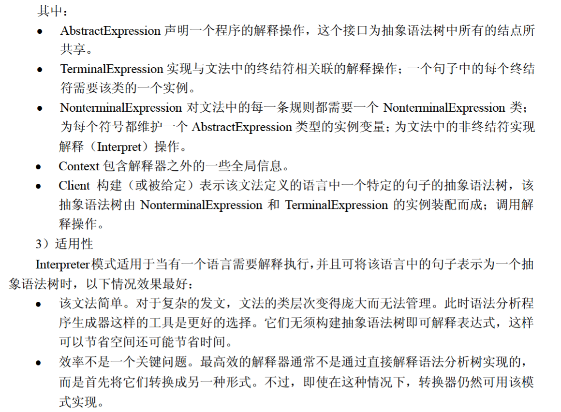

代码
import java.util.*;

public class InterpreterPattern {
public static void main(String[] args) {
Context context = new Context();

context.check("A区的开发人员");
context.check("B区的调试人员");
context.check("C区的测试人员");

System.out.println("==========");

context.check("D区的程序员");
context.check("D区的测试员");
context.check("A区的程序员");
}
}

class Context {
private String[] regions = {"A区", "B区", "C区"};
private String[] persons = {"开发人员", "测试人员", "调试人员"};

private NonterminalExprssion nonterminal;

public Context() {
TerminalExpression region = new TerminalExpression(regions);
TerminalExpression person = new TerminalExpression(persons);
nonterminal = new NonterminalExprssion(region, person);
}

public void check(String info) {
boolean bool = nonterminal.Interpret(info);
if (bool) {
System.out.println("识别成功");
} else {
System.out.println("识别失败");
}
}
}

interface Expression {
public boolean Interpret(String info);
}

class NonterminalExprssion implements Expression {
private TerminalExpression region;
private TerminalExpression person;

public NonterminalExprssion(TerminalExpression region, TerminalExpression person) {
this.region = region;
this.person = person;
}

@Override
public boolean Interpret(String info) {
String[] str = info.split("的");
// B区的调试人员 --> str = {"B区", "调试人员"}

return region.Interpret(str[0]) && person.Interpret(str[1]);
}
}

class TerminalExpression implements Expression {
private Set<String> set = new HashSet<>();

public TerminalExpression(String[] data) {
// for (遍历对象类型 对象名 : 遍历对象)
for (String str : data) {
set.add(str);
}
}

@Override
public boolean Interpret(String info) {
return set.contains(info);
}
}

