视频P51：https://www.bilibili.com/video/BV18L4y1M7Bd?p=51

迭代器模式
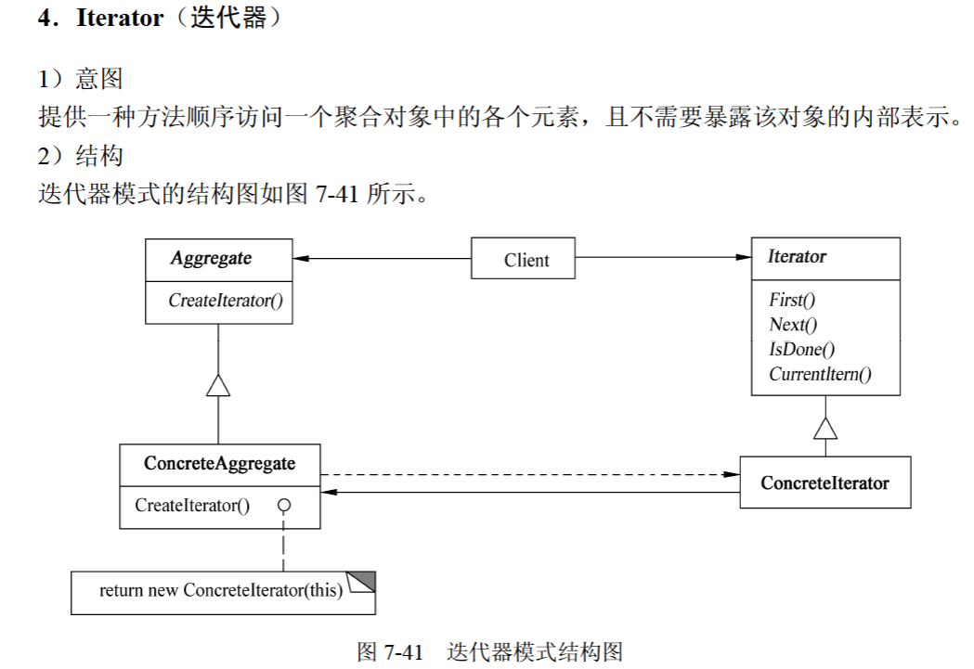
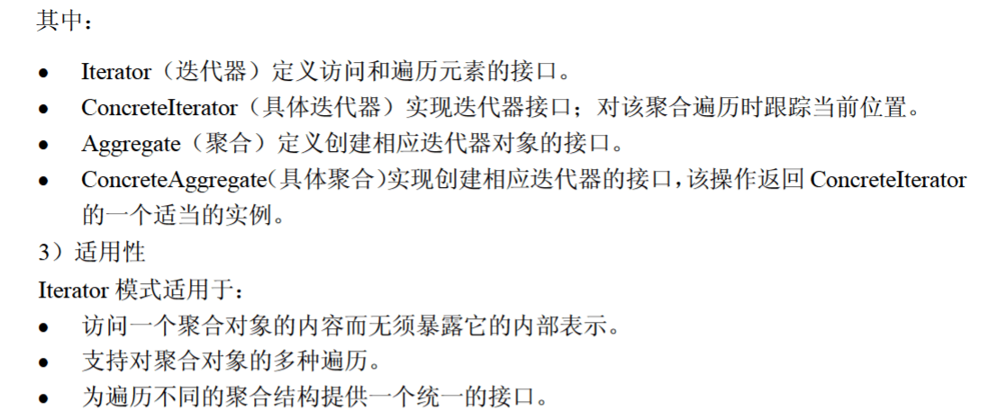

代码
import java.util.*;

public class IteratorPattern {
public static void main(String[] args) {
BookAggregate bookAggregate = new BookAggregate();

String[] books = {"数据结构", "操作系统", "计算机网络", "计算机组成原理"};
double[] prices = {10.24, 20.48, 40.96, 81.92};

for (int i = 0; i < 4; i ++ ) {
bookAggregate.Add(new Book(books[i], prices[i]));
}

Iterator bookIterator = bookAggregate.CreateIterator();
while (bookIterator.hasNext()) {
Book book = (Book) bookIterator.next();
System.out.println(book.getName() + " " + book.getPrice());
}
}
}

interface Iterator {
public boolean hasNext();
public Object next();
}

class BookIterator implements Iterator {
private int index;
private BookAggregate bookAggregate;

public BookIterator(BookAggregate bookAggregate) {
this.index = 0;
this.bookAggregate = bookAggregate;
}

@Override
public boolean hasNext() {
if (index < bookAggregate.getSize()) {
return true;
} else {
return false;
}
}

@Override
public Object next() {
Object obj = bookAggregate.get(index);
index ++ ;

return obj;
}
}

interface Aggregate {
public Iterator CreateIterator();
}

class BookAggregate implements Aggregate {
private List<Book> list = new ArrayList<Book>();

public void Add(Book book) {
list.add(book);
}

public Book get(int index) {
return list.get(index);
}

public int getSize() {
return list.size();
}

@Override
public Iterator CreateIterator() {
return new BookIterator(this);
}
}

class Book {
private String name;
private double price;

public Book(String name, double price) {
this.name = name;
this.price = price;
}

public String getName() {
return name;
}

public double getPrice() {
return price;
}
}

