视频P〜P：https://www.bilibili.com/video/BV18L4y1M7Bd?p=15

原型模式
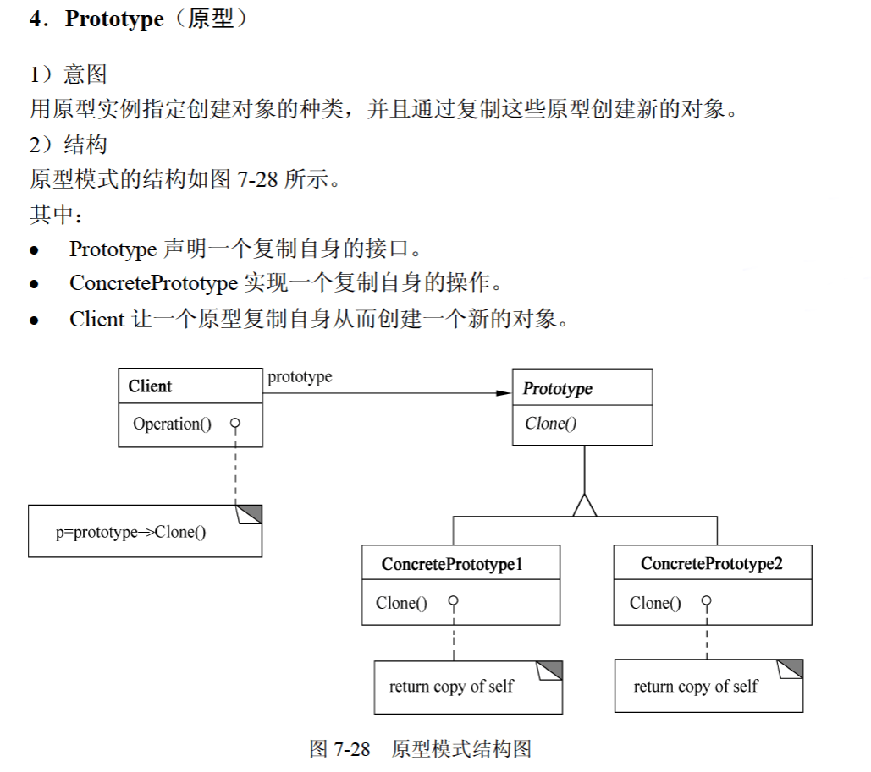
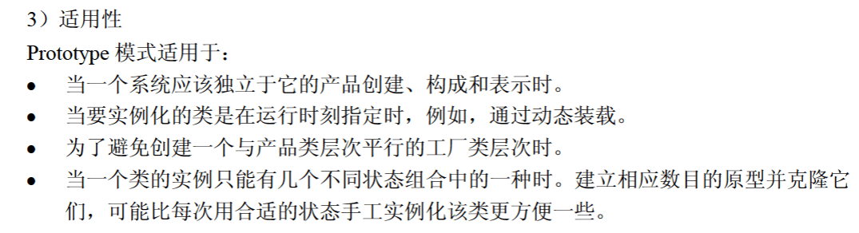

代码
public class Main {
public static void main(String[] args) {
Product product1 = new Product(2022, 5.28);
System.out.println(product1.getId() + " " + product1.getPrice());

// Product product2 = new Product(2022, 5.28);
Product product2 = (Product) product1.Clone();
System.out.println(product2.getId() + " " + product2.getPrice());

Product product3 = (Product) product1.Clone();
System.out.println(product3.getId() + " " + product3.getPrice());
}
}

interface Prototype {
public Object Clone();
}

class Product implements Prototype {
private int id;
private double price;

public Product() {}

public Product(int id, double price) {
this.id = id;
this.price = price;
}

public int getId() {
return id;
}

public double getPrice() {
return price;
}

@Override
public Object Clone() {
Product object = new Product();
object.id = this.id;
object.price = this.price;

return object;
}
}

