2012年上半年试题六
阅读下列说明和Java代码，将应填入 （n） 处的字句写在答题纸的对应栏内。
【说明】
某咖啡店当卖咖啡时，可以根据顾客的要求在其中加入各种配料，咖啡店会根据所加入的配料来计算费用。咖啡店所供应的咖啡及配料的种类和价格如下表所示。
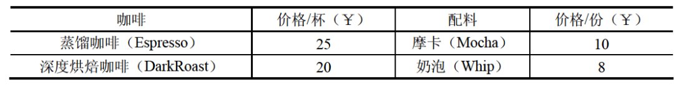
现采用装饰器（Decorator）模式来实现计算费用的功能，得到如图6-1所示的类图
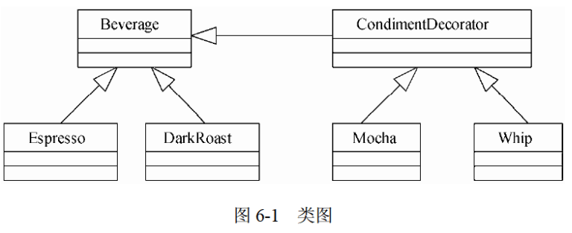

【Java代码】
import java.util.*;

(1) class Beverage { // 饮料
String description = "Unknown Beverage";
public (2) () { return description; }
public (3) ;
}

abstract class CondimentDecorator extends Beverage { // 配料
protected (4) ;
}
class Espresso extends Beverage { // 蒸馏咖啡
private final int ESPRESSO_PRICE = 25;
public Espresso() { description = "Espresso"; }
public int cost() { return ESPRESSO_PRICE; }
}

class DarkRoast extends Beverage { // 深度烘焙咖啡
private final int DARKROAST_PRICE = 20;
public DarkRoast() { description = "DarkRoast"; }
public int cost() { rcturn DARKROAST PRICE; }
}

class Mocha extends CondimentDecorator { // 摩卡
private final int MOCHA_PRICE = 10;
public Mocha (Beverage beverage) { this.beverage = beverage; }
public String getDescription() {
return beverage.getDescription() + ", Mocha";
}
public int cost() { return MOCHA_PRICE + beverage.cost(); }
}

class Whip extends CondimentDecorator { // 奶泡
private final int WHIP_PRICE = 8;
public Whip (Beverage beverage) { this.beverage = beverage; }
public String getDescription() {
return beverage.getDescription() + ", Whip";
}
public int cost() { return WHIP_PRICE + beverage.cost(); }
}

public class Coffee {
public static void main(String args[]) {
Beverage beverage = new DarkRoast();
beverage = new Mocha( (5) );
beverage = new Whip ( (6) );
System.out.println(beverage.getDescription() +" ￥"+ beverage.cost());
}
}

编译运行上述程序，其输出结果为：
DarkRoast, Mocha, Whip ￥38

解析在下一页！

视频解析P31：https://www.bilibili.com/video/BV1XT4y1v7ih?p=31

文字解析：下方
