2019年下半年试题六
阅读下列说明和Java代码，将应填入 （n） 处的字句写在答题纸的对应栏内。
【说明】
某文件管理系统中定义了类OfficeDoc和DocExplorer。当类OfficeDoc发生变化时，类DocExplorer的所有对象都要更新其自身的状态。现采用观察者（Observer）设计模式来实现该需求，所设计的类图如图6-1所示。
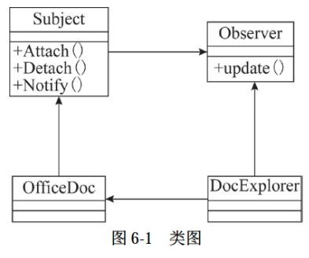
【Java代码】
import java.util.*;

interface Observer {
public (1) ;
}

interface Subject {
public void Attach(Observer obs);
public void Detach(Observer obs);
public void Notify();
public void setStatus(int status);
public int getStatus();
}

class OfficeDoc implements Subject {
private List< (2) > myObs;
private String mySubjectName;
private int m_status;
public OfficeDoc(String name) {
mySubjectName = name;
this.myObs = new ArrayList<Observer>();
m_status = 0;
}
public void Attach(Observer obs) { this.myObs.add(obs); }
public void Detach(Observer obs) { this.myObs.remove(obs); }
public void Notify() {
for (Observer obs : this.myObs) { (3) ; }
}
public void setStatus(int status) {
m_status = status;
System.out.println("SetStatus subject[" + mySubjectName + "]status:" + status);
}
public int getStatus() { return m_status; }
}

class DocExplorer implements Observer {
private String myObsName;
public DocExplorer(String name, (4) sub) {
myObsName = name;
sub. (5) ;
}
public void update() {
System.out.println("update observer[" + myObsName + "]");
}
}

class ObserverTest {
public static void main(String[] args) {
Subject subjectA = new OfficeDoc("subject A");
Observer observerA = new DocExplorer("observer A", subjectA);
subjectA.setStatus(1);
subjectA.Notify();
}
}

解析在下一页！

视频解析P40：https://www.bilibili.com/video/BV1XT4y1v7ih?p=40

文字解析：下方
